### Saudi Tourism Authority

Saudi Rewards - About Us Page

November 2023

**About Us Page**

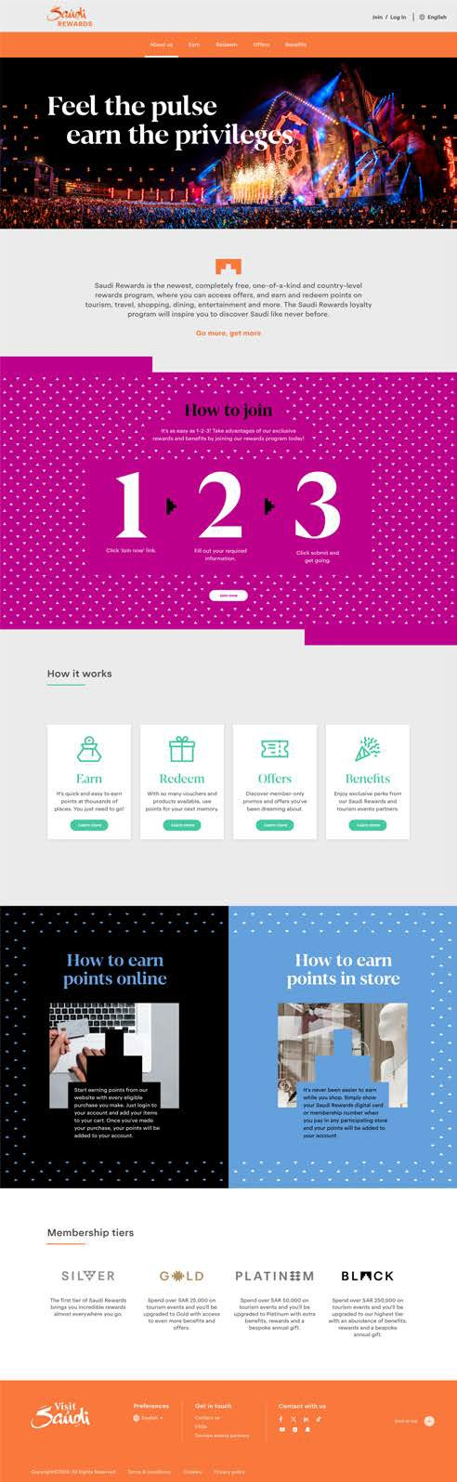

[header component]

[H1] Feel the pulse,

earn the privileges

[intro component]

[body text]

Get inspired to experience Saudi like never before! Saudi Rewards is Saudi’s newest, completely free, first-of-its-kind national rewards program. You can earn and redeem points on tourism events and curated travel deals through our partners, get exclusive unmatched experiences, and offers such as discounts on shopping, dining, excursions and entertainment.

Go more, get more.

[centered text/graphic component]

[H2] How to Join

[body text] It’s as easy as 1-2-3! Take advantage of exclusive benefits by joining Saudi Rewards today!

[number visual] 1 - 2 - 3

[text under number 1] Click the “Join Now” button

[text under number 2] Fill out your required information

[text under number 3] Click submit and get going

[button]Join Now

[CTA] rewards.visitsaudi.com/en/join

[card component]

[H2] How It Works

[card 1]

[H2] Earn

[body text] Earn when you spend with our tourism and travel partners.

[button] Learn More

[CTA] rewards.visitsaudi.com/en/rewards

[card 2]

[H2] Redeem

[body text] Redeem points on event tickets and curated tourism experiences.

[button] Learn More

[CTA] rewards.visitsaudi.com/en/rewards

[card 3]

rewards.visitsaudi.com/en/rewards

[card 4]

[H2] Benefits

[body text] Unlock experiences money can’t buy with member-only offers and deals.

[button] Learn More

[CTA] rewards.visitsaudi.com/en/rewards

[side-by-side component]

[H2] How to Earn Points Online

[body text] Start earning points from our website when you spend on travel packages or through tourism partners. Just log in to your account and add items to your cart on eligible partners’ websites. Once you’ve made your purchase, your points will be added to your account.

[H2] How to Earn Points in Store

[body text] It’s never been easier to earn while you shop. Simply show your Saudi Rewards digital card or membership number when you pay at any participating partner, and your points will be added to your account.

[column component]

[H2] Membership Tiers

[column 1]

[Silver Tier Logo]

[body text] Start at Silver and earn points, benefits and offers from the moment you sign up. It’s free to join and only gets better the further you go.

[column 2]

[Gold Tier Logo]

[body text] Advance to Gold once you spend SAR25,000 on eligible purchases. At this level, you’ll earn 1.5 Saudi points for every SAR1 spent, and your points remain valid for 24 Months.

[column 3]

[Platinum Tier Logo]

[body text] Reach Platinum once you spend SAR50,000 on eligible purchases. At this level, you’ll earn 2 Saudi points for every SAR1 spent, and your points remain valid for 30 Months.

[column 4]

[Black Tier Logo]

[body text] Achieve Black status once you spend SAR250,000 on eligible purchases. At this elite level, you’ll earn 3 Saudi points for every SAR1 spent, and your points remain valid for 36 Months.

[button] Find Your Membership Tier

[CTA] rewards.visitsaudi.com/en/membership-tiers

SEO

Meta Title: About Us | Saudi Rewards

Meta Description: Discover Saudi Rewards, a national rewards program redefining travel. Earn more points and unlock more rewards on your next trip to Saudi Arabia.

URL: /en/about